CSI- 2K24 Achievements
KSRMCE CSI Coordinators:
- B. Swetha, Assistant Professor, Department of CSE
- A. Ramprakash Reddy, Assistant Professor, Department of CSE
have got “Best Student Branch Counselor” awards for KSRM CSI Student branch Coordinators in CSI Annual Excellence Awards- 2024 organized by Computer Society of India (CSI) HYD Chapter. Award distributed by Inauguration of Awards function & Address by the Smt. Shailaja Rama Iyer Vice Chancellor – PSTU, Principal Secretary Endowments, Handlooms & Textiles and Handicrafts –, Former VC - JNTUH. The event was held on Saturday, 29th June 2024, at Potti Sreeramulu Telugu University, Public Gardens, Hyderabad.

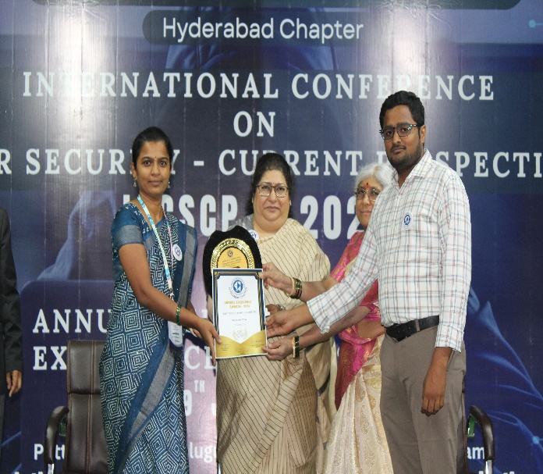
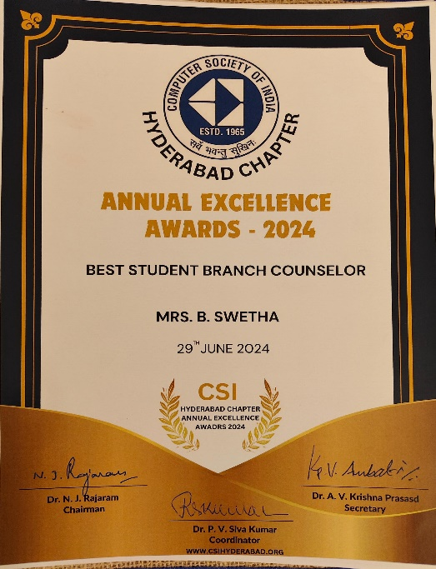 | 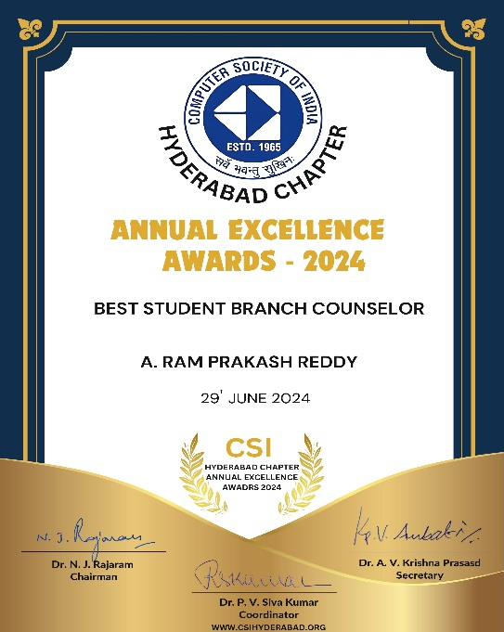

Department of CSE and AIML faculty and Students participated and presented papers in ICCSCP-2024 International Conference on Cyber Security - Current perspectives organized by Computer society of India on 29th June 2024.
Details of paper presented
1. B. Swetha, Assistant Professor, Dept. of CSE, G.Vijaya Deeksha B.Tech 2nd year, Dept. of CSE and P.Pochamma, B.Tech 3rd year, Dept. of AIML, has participated in International Conference on Cyber Security- Current Perspectives (ICCSCP-2K24) and paper presented and selected as BEST Paper Award on the topic “Digital Defenders: Fighting Back Against Cyber Attacks” held on 29th June 2024, organized by the Computer Society of India(CSI) HYD Chapter, Hyderabad.
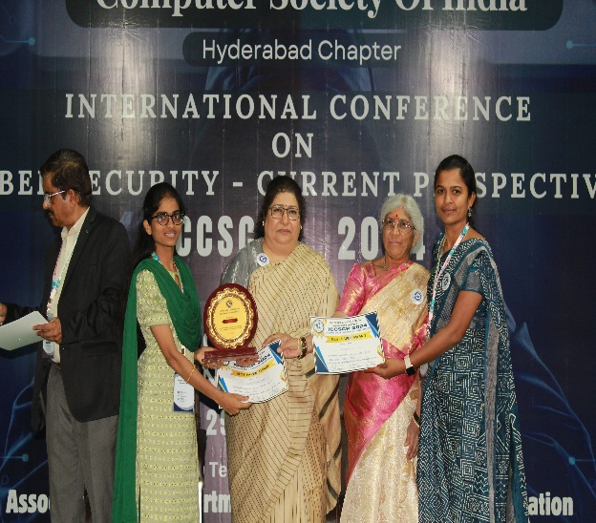 | 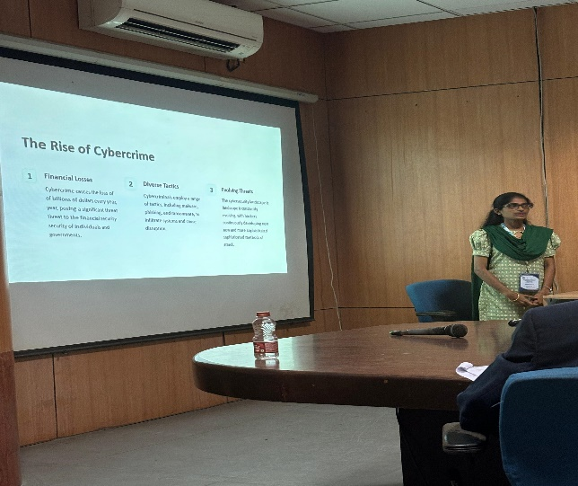

2. A. Ramprakash Reddy, Assistant Professor, Dept. of CSE, A. Dinesh Kumar Reddy, B.Tech 2nd year, Dept. of CSE and P. Ram Sai Pravallika, B.Tech 3rd year, Dept. of AIML, has participated in International Conference on Cyber Security- Current Perspectives (ICCSCP-2K24) and paper presented on the topic “Cybersecurity Threats and Countermeasures” held on 29th June 2024, organized by the Computer Society of India(CSI) HYD Chapter, Hyderabad.

3. G. Balaji Reddy, B.Tech 3nd year, Dept. of AIML and M. Sai Charan Reddy, B.Tech 3rd year, Dept. of AIML, has participated in International Conference on Cyber Security- Current Perspectives (ICCSCP-2K24) and paper presented on the topic ““Introduction to Cybersecurity with AI”” held on 29th June 2024, organized by the Computer Society of India(CSI) HYD Chapter, Hyderabad.
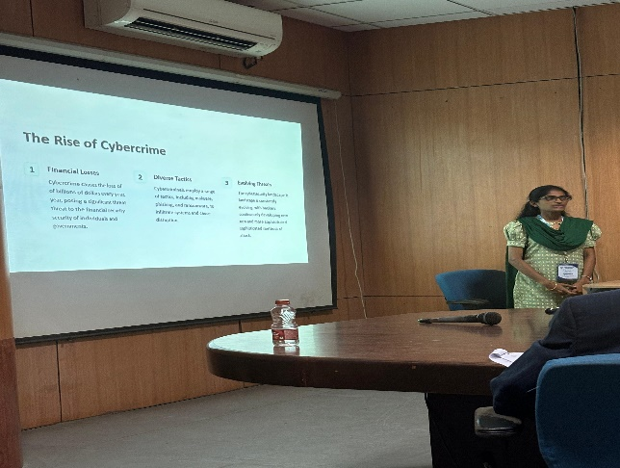 | 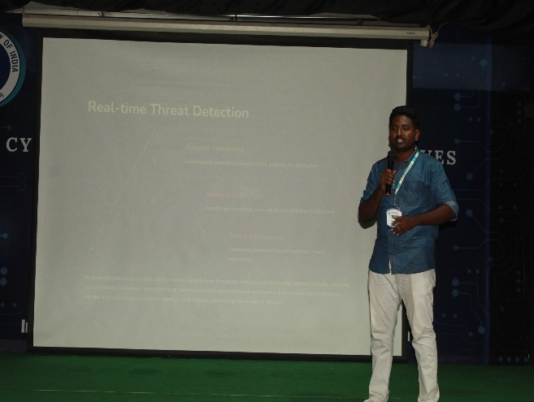
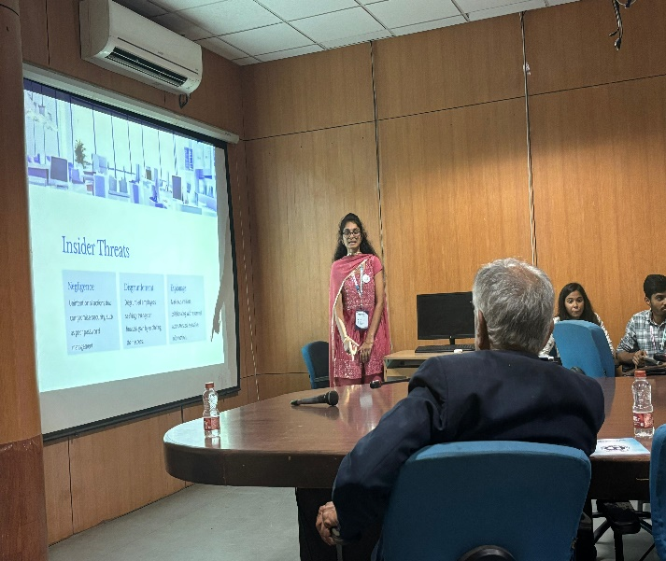 | 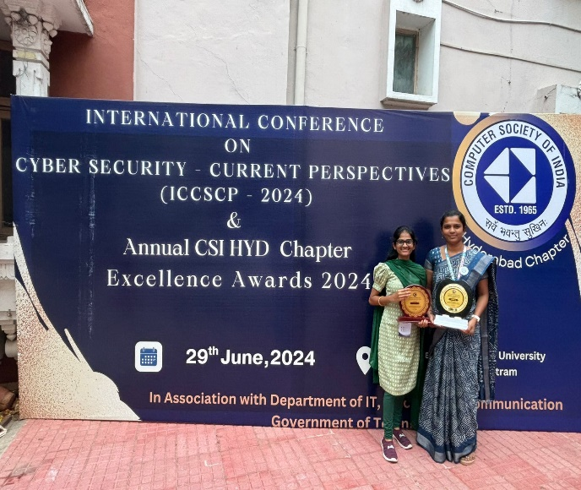
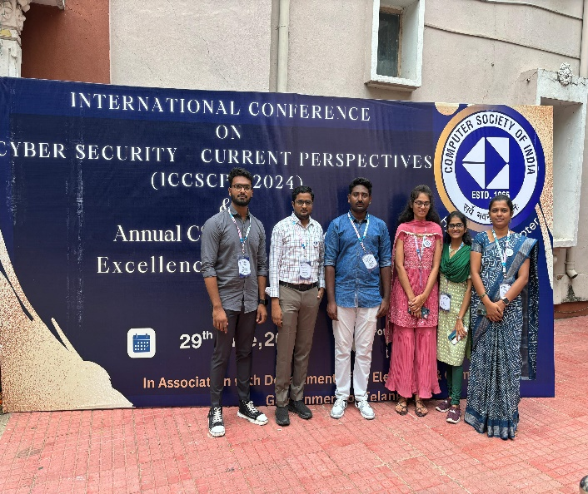 | 